Template for Preparation of 2 pages Abstracts for 6th Korea- Japan- China Joint Workshop on Fluid Power

Author¹, Author ² and Author ^{3*} (Name in English, Times New Roman 11pt)
1 Department of Mechanical Engineering, University of Ulsan, Korea
2 Department of Mechanical Engineering, University of Ulsan, Korea
3 Department of Mechanical Engineering, University of Ulsan, Korea
* Corresponding: author@ulsan.ac.kr
This is the template for two-page abstracts. Please use this template in making up your document, by removing each section of text and replacing it with your own writing. For instance, select the whole title above and type in your title; then select the first author lines and type in the name, affiliation, and email address; then select the second author and type in the name and affiliation; etc. This will preserve the formatting. Delete any material that you don’t use.
The first paragraph immediately above has special formatting (12 points of space before it, and no indent), but successive paragraphs are all the same and you can select them all, delete them, and type your text as needed.
All fonts are “Times New Roman”. The title is 14-point, the main body text is 11-point, and the references, which should be preferably supplied in the text page, are 10-point. Please, identify a call to a reference using brackets [1]. Text is in one column and left-justified, except for the title and authors, which are centered on the page. The abstract should present the aim of the work, essential results and conclusion. The total length of the short abstract should not exceed two-page long on A4 Standard (21 cm x 29.7 cm): one text page (1000 words or less, 11 point font) and another page with figures and tables [2].
Figures should be supplied in the second page, and they should be provided with explanatory figure captions [3]. Please, use “Times New Roman” 11-point for the captions as well. There are no specific instructions for the placing, number and sizes of the figures, as long as they are clearly visible. If you need to include tables, you can also do such in the second page of the abstract. Please, use the 11-point font both for the table and for its caption.
After proofreading your paper, it must be submitted by sending email to the following mail: pageplan3389@liveuou.kr with PDF and DOC formats.

References
- J. Smith, “Static friction effects during for tasks and their implications for manipulator design,” Int. J Robot. Res., vol. 15, no. 6, pp. 508–510, 1998.
- M. T. Mason and J. K. Salisbury, Robot Hands and the Mechanics of Manipulation. Cambridge, MA: MIT Press, 1985.
- B. J. Li and R. A. Freeman, “Synthesis of actively adjustable springs by antagonistic redundant actuation,” ASME J. Dyn Syst., Measur. Contr., vol. 114, pp. 454–461, 1992.

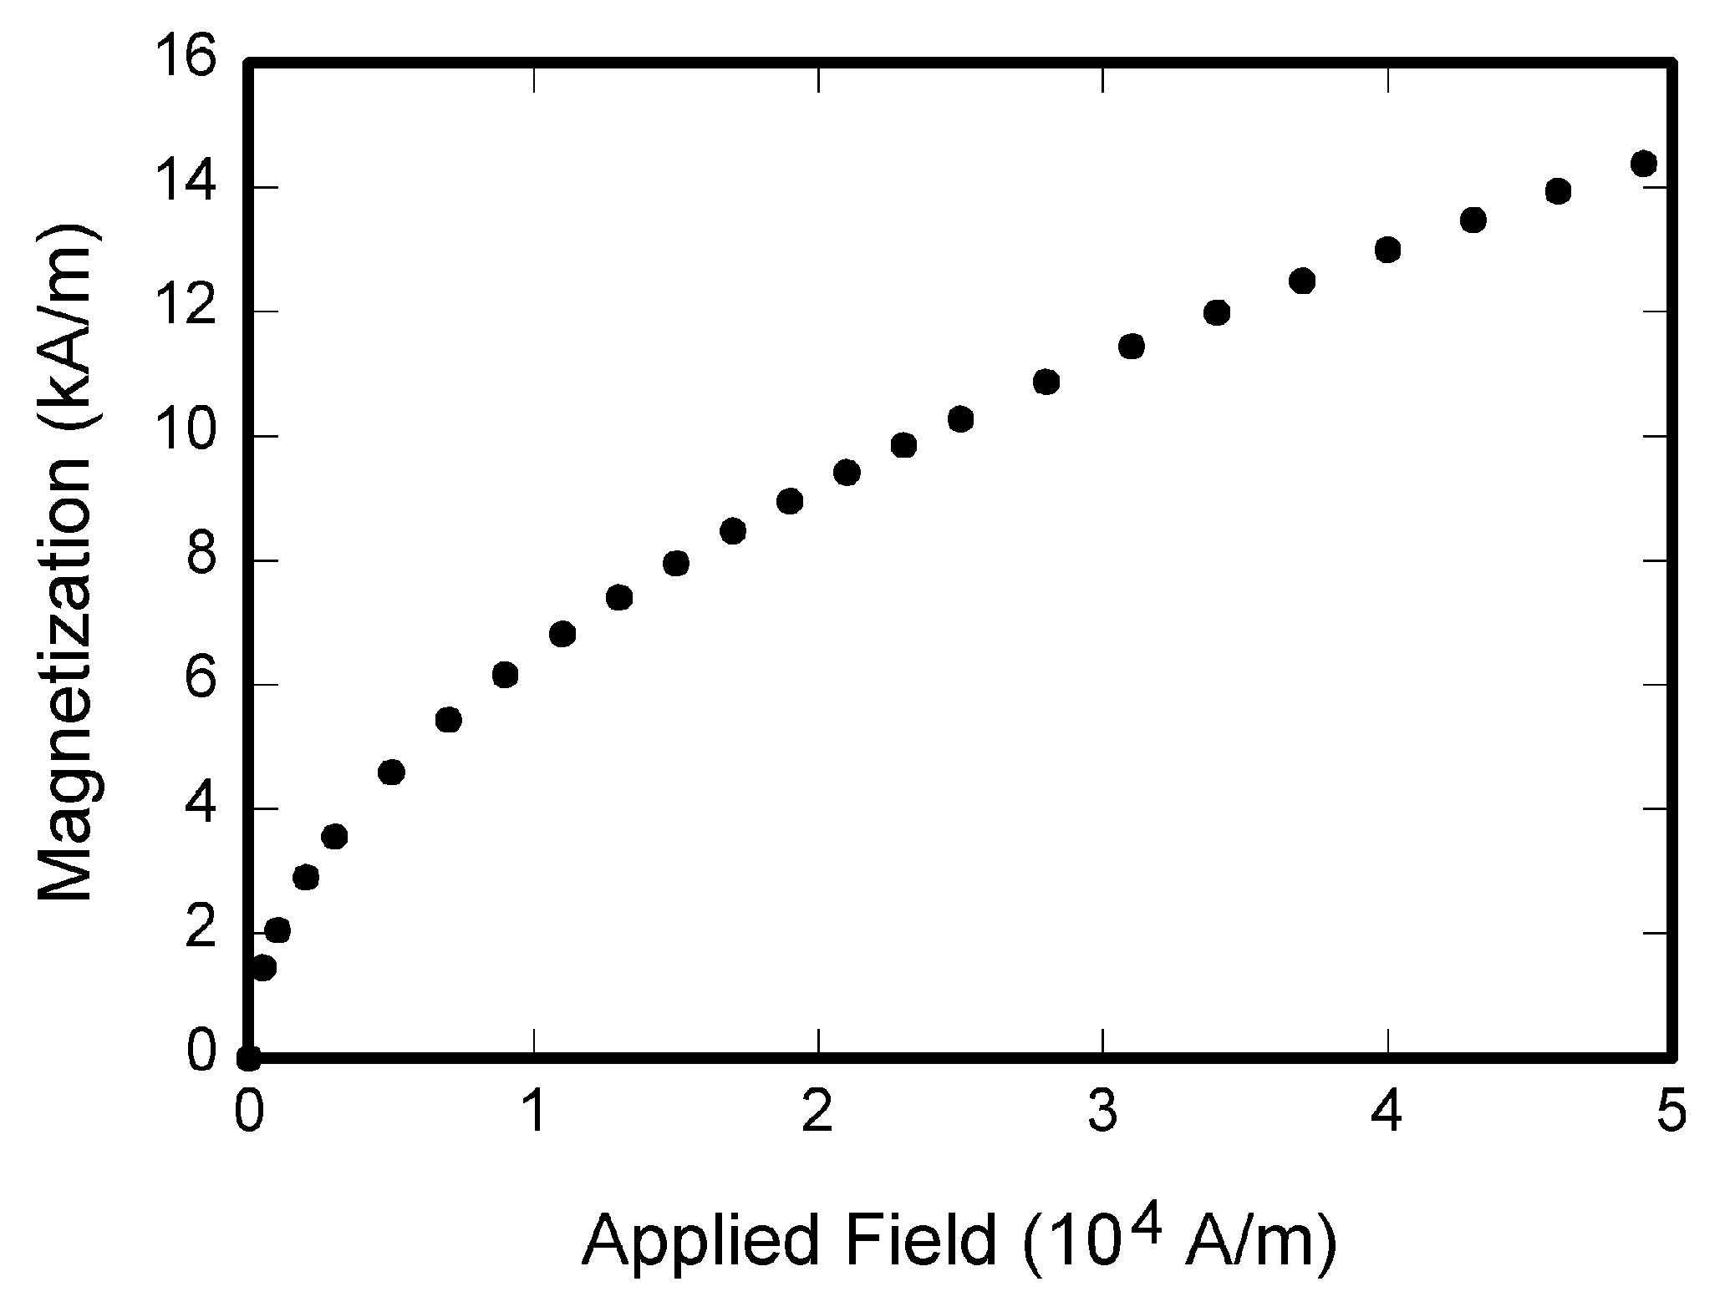
Figure 1. This is an example of a figure. Please, make use that any lettering or symbols are clearly readable.

