1. Introduction
A Study on the Japan Fluid Power System Society*
(1st Report: Template Document File)
Taro YUATSU**, Jiro KUATSU**, Hanako SUIATSU***
This paper is concerned with the Japan Fluid Power System Society (JFPS). The JFPS is an academic society for the purpose of publication, communication, and exchange of knowledge and information on fluid power systems including hydraulics, pneumatics, water hydraulic system and functional fluid technology. It has more than a 30 year history. The contribution rules are regulated for the Transactions of the JFPS. The papers published in the Transactions of the JFPS are coincidentally reported in the JFPS International Journal of Fluid Power System on web. The papers contributed to the Transactions of the JFPS will be accepted without the distinction between the JFPS members and non-members. Papers must be original and previously unpublished research that has reference to the field of engineering and technology treated in the JFPS. Papers must be contributive for engineering or useful as fresh technology in industry. The length of the paper should be provided within 6 pages in principle. It is required that a contributor fill in a Manuscript Submission and Gist Explanation Form designated by the JFPS, and send it with the paper to the JFPS in electronic form. The Manuscript Submission and Gist Explanation Form can be downloaded from the JFPS homepage.
Keywords: Hydraulics, Pneumatics, Water Hydraulic System, Functional Fluid (See http://www.jfps.jp/04_02.html)
Manuscript Template for the JFPS International Journal of Fluid Power System
The Japan Fluid Power System Society is an academic society for the purpose of publication, communication, and exchange of knowledge and information on fluid power systems including hydraulics, pneumatics, water hydraulic system and functional fluid technology. It has more than a 30 year history¹⁾⁻⁴⁾.

2. Nomenclature
a | : | sound velocity
p | : | pressure
Q | : | flow rate
t | : | time
v | : | velocity
x | : | displacement
α | : | angle
μ | : | viscosity
σ | : | electric conductivity
Subscript
1 | : | inlet
n | : | number

3. Major Events
* Manuscript received December 25, 2009
** University of Fluid Power
(Koen 1-2-3 Minato-ku Tokyo, Japan)
E-mail: taro@yuatsu.com
*** Fluid System Co. Ltd.
(Yamanote 4-5-6 Yokohama, Kanagawa, Japan)

3.1 Ordinary General Meeting
It is usually held in May, after the Annual Spring Conference in Tokyo.

3.2 Annual Conference
There are the Annual Spring/Autumn Conferences held in Tokyo and other cities, respectively. In average, 40-50 papers and 140 attendants are always expected during 2 or 3 day conference.

3.3 International Symposium
The 7th JFPS International Symposium, Toyama was held in November 2008 ⁴⁾. The next symposium will be held on 25-28 October, 2011 in Okinawa.

3.4 Training Course
Training courses are annually planned for the society members. Themes are pneumatics and simulation, etc.

3.5 Seminar
Autumn and Winter Seminars are planned. Topics of recent seminars include electric or fluid-power drive, environmental issues for fluid power systems and recent trends on noise and vibration.

4. Publications
The JFPS publishes the Journal of the Japan Fluid Power System Society. There are 6 printed issues and 1 electronic issue per year. The JFPS also publishes the Transactions of the Japan Fluid Power System Society having 6 issues per year, including about 20 research papers.
4.1 Font
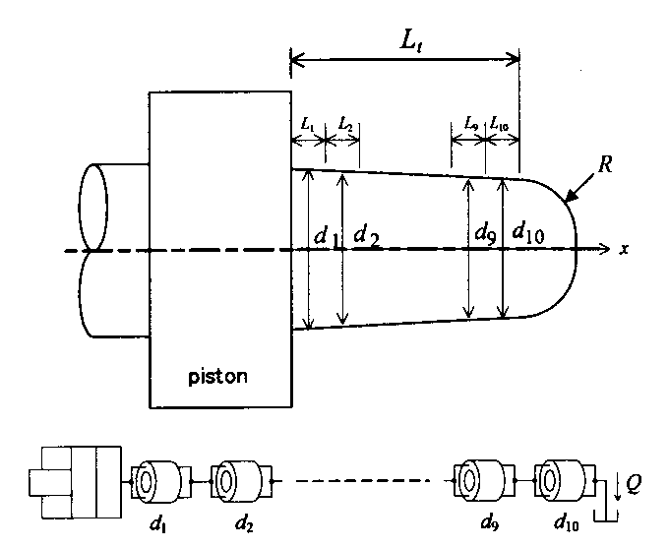 Fig.1 Model of cushion plunger
Times New Roman with the following font sizes should be used:
(a)Title: 14 point, bold
(b)Subtitle: 12 point, bold
(c)Authors’ names: 12 point
(d)Abstract, keywords and text: 9 point
(e)Captions of figures and tables: 8 point
(f)Headings of sections: 10.5 point, bold
(g)Headings of subsections: 9 point, bold
Table 1 Physical properties of test oils at 313K
(σ : electric conductivity, μ : viscosity)
Oil No. | σ [S/m] | μ [Pa･s]
1 | 5.31×10⁻¹² | 9.97×10⁻³
2 | 1.35×10⁻¹⁰ | 19.4×10⁻³
3 | 1.24×10⁻¹⁰ | 39.4×10⁻³

4.2 Equations
An equation should be written from the third letter of the line and the equation number should be written at the end of the line as follows:
$\frac{dx}{dt}=v+a$ (1)
4.3 Figures and Tables
Figures and tables should be inserted at the appropriate places in the text. For higher legibility, a proper margin should be assigned to the spaces between
(a)Figure/table and its caption
(b)Last line of previous paragraph and figure/table
(c)Figure/table and first line of successive paragraph
The caption of a figure/table should be centered on the line. Only the first letter of the first word in the caption of a figure/table should be capitalized.

References
- Yuatsu, T. et al.: A Study of Performance Improvement of a Compressor, Transaction of the Japan Fluid Power System Society, Vol.3, No.4, p.56-62 (2001)
- Suzuki, I., Matsui, H., Matsuzaka, D.: Fundamentals of Water Hydraulic Control, New York Press, p.123-124 (1970)
- Obama, B., Bush, G. W.: Development of Super-Intelligent Fluid Power System, Proceedings of 7th JFPS International Symposium on Fluid Power, p.645-650 (2008)
- http://www.jfps.jp (accessed on 1 January, 2020)

