1. Introduction

**Study on the Japan Fluid Power System Society (A Template Document File)**

Taro YUATSU1, Jiro KUKIATSU2, Hanako SUIATSU3

1 University of Fluid Power (Koen 1-2-3 Minato-ku Tokyo, Japan)

2 University of Fluid Power (Koen 1-2-3 Minato-ku Tokyo, Japan) Jiro@yuatsu.comt.ac.jp (corresponding author)

3 Fluid System Co., Ltd. (Yamanote 4-5-6 Yokohama, Kanagawa, Japan)

**Received ** May 20** / Accepted ** *** 20\*\***

This paper is concerned with the Japan Fluid Power System Society (JFPS). The JFPS is an academic society for the purpose of publication, communication, and exchange of knowledge and information on fluid power systems including hydraulics, pneumatics, water hydraulic system and functional fluid technology. It has more than a 50 year history. The contribution rules are regulated for the Transactions of the JFPS. The papers published in the Transactions of the JFPS are coincidentally reported in the JFPS International Journal of Fluid Power System on web. The papers contributed to the Transactions of the JFPS will be accepted without the distinction between the JFPS members and non-members. Papers must be original and previously unpublished research that has reference to the field of engineering and technology treated in the JFPS. Papers must be contributive for engineering or useful as fresh technology in industry. The length of the paper should be provided within eight pages in principle. It is required that a contributor fill in a Manuscript Submission designated by the JFPS, and send it with the paper to the JFPS in electronic form. The Manuscript Submission and Gist Explanation Form can be downloaded from the JFPS homepage. In 2021 the design and manuscript template of the JFPS International Journal of Fluid Power System was renewed.

**Keywords**: Hydraulics, Pneumatics, Water Hydraulic System, Functional Fluid, Fluid Power, Format, English (See https://www.jfps.jp/eng/e02_03.html for keywords)

The Japan Fluid Power System Society is an academic society for the purpose of publication, communication, and exchange of knowledge and information on fluid power systems including hydraulics, pneumatics, water hydraulic system and functional fluid technology. It has more than a 50 year history1)-8).

The JFPS International Journal of Fluid Power system provides novel contributions for researchers and engineers who devote themselves to modern fluid power components and systems related to the fields from fluid analyses, control system, energy saving, from theory to application, and from software to hardware. Newly developed interdisciplinary ideas and concepts transferable from one field to another are also welcome. The journal seeks original manuscripts for publication. All papers are peer reviewed by at least two leading experts of the JFPS community to ensure both technical quality and integrity.

2. Nomenclature

|  |  |  |
| --- | --- | --- |
| $$a$$ | : | sound velocity |
| $$p$$ | : | pressure |
| $$Q$$ | : | flow rate |
| $$T$$ | : | representative time |
| $$t$$ | : | time |
| $$v$$ | : | velocity |
| $$x$$ | : | displacement |
| $$α$$ | : | angle |
| $$μ$$ | : | viscosity |
| $$σ$$ | : | electric conductivity |
| $$τ$$ | : | normalized time, $τ=t/T$ |
| Subscript | | |
| $$n$$ | : | number |
| $$0$$ | : | reference |
|  | : | inlet |

3. Template File

This is the file of “Manuscript Template for the JFPS International Journal of Fluid Power System.” Please also download the files of the latest version of “Submission Rules for Papers in JFPS International Journal of Fluid Power System” and “Writing Guidelines for Papers in JFPS International Journal of Fluid Power System” from the JFPS website and read them carefully before writing your manuscript and submitting your contribution.

4. Publications

The JFPS publishes the JFPS International Journal of Fluid Power System. The JFPS also publishes the Journal of the Japan Fluid Power System Society and the Transactions of the Japan Fluid Power System Society (in Japanese).

**4.1 Font**

Times New Roman with the following font sizes should be used:

(a) Title: 14 point, bold

(b) Authors’ names: 12 point

(c) Affiliation, E-mail (corresponding author only): 9 point

(d) Abstract, Keywords and text: 9 point

(e) Captions of figures and tables: 8 point

(f) Headings of sections: 10.5 point, bold

(g) Headings of subsections: 9 point, bold

(h) References: 8 point

**4.2 Equations**

An equation should be left aligned and numbering right aligned as follows:

|  |  |
| --- | --- |
| $$\frac{dx}{dt}=v+a$$ | (1) |

**4.3 Figures and Tables**

Figures and tables should be inserted at the appropriate places in the text. For higher legibility, as shown in Fig. 1 and Table 1, a proper margin should be assigned to the spaces between

(a) Figure/table and its caption

(b) Last line of previous paragraph and figure/table

(c) Figure/table and first line of successive paragraph

The caption of a figure/table should be left aligned and hanging indent. Only the first letter of the first word in the caption of a figure/table should be capitalized.

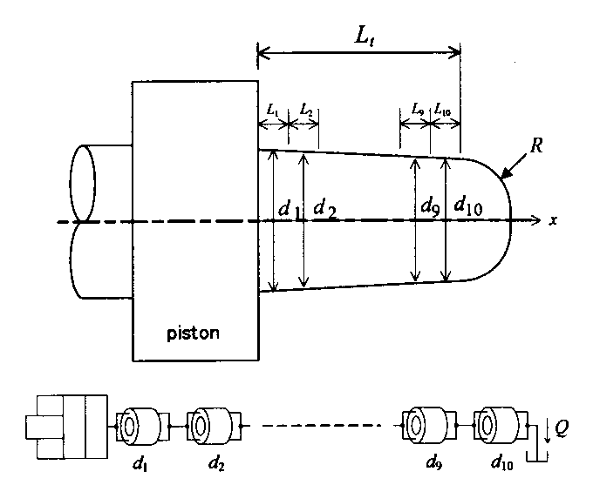

Fig. 1 Model of cushion plunger ($d_{1, ⋯, 10}$: diameter, $L_{1, ⋯, 10, t}$: length, $Q$: flow rate, $R$: radius, $x$: coordinate)

Table 1 Physical properties of test oils at 313 K ($σ$: electric conductivity, $μ$: viscosity)

|  |  |  |
| --- | --- | --- |
| Oil No. | $σ$ S/m | $μ$ Pa⋅s |
| 1 | 5.31×10-12 | 9.97×10-3 |
| 2 | 1.35×10-10 | 19.4×10-3 |
| 3 | 1.24×10-10 | 39.4×10-3 |

References

1. Yuatsu, A. and Kukiatsu, B.: A Study of Performance Improvement of a Compressor, JFPS International Journal of Fluid Power System, Vol. 3, No. 4, pp. 56–62 (2001), DOI: 10.5739 /jfpsij.5.67
2. Oil, M. and Pneumatic A.: Basics of Fluid Power, Journal of Japan Fluid Power System Society, Vol. 52, No. 7, pp. 123–132 (2021) (in Japanese)
3. Suzuki, I., Matsui, H., and Matsuzaka, D.: Fundamentals of Water Hydraulic Control, New York Press, pp. 123–124 (1970)
4. Air, C. and Water, H.: Development of Super-Intelligent Fluid Power System, Proceedings of 7th JFPS International Symposium on Fluid Power, pp. 645–650 (2020), DOI: 10.5739/isfp.2020.000
5. Japan Fluid Power System Society: JFPS International Journal of Fluid Power System, http://www.jfps.jp/eng/e02_01.html (accessed on 29 August, 2021)
6. Yukuatsu, G.: Device of Functional Fluid, JP,2021-000000 (2021)
7. Japan Hydraulics and Pneumatics Society: Shinpan Yukuatsu Binran, Ohmsha, Ltd. (1989) (in Japanese)
8. Japan Fluid Power System Society: Yuatsu Kiban Gijutu, Denshou to Katsuyou, Japan Industrial Publishing Co., Ltd. (2014) (in Japanese)



© 20** The Japan Fluid Power System Society. This is an open access article under the terms of the Creative Commons Attribution-NonCommercial-NoDerivs license (https://creativecommons.org/licenses/by-nc-nd/4.0/).